EFFECTS OF KRATOM
Name:
Institution:

EFFECTS OF KRATOM
Introduction
Kratom which is also commonly referred to as Mitragyna speciosa korth is a drug that is mostly found in Southeast Asia, Malaysia, Indonesia and Thailand. The drug is extracted from leaves of the ever green tree and it is believed that the leaves contain psychoactive elements that stimulate one who consumes the drug. When talking about drug abuse and drugs that people use you always think of the common drugs such as marijuana, crack cocaine, heroin, and meth. Consider there are many more drugs out there than you may think. For example, Kratom (Mitragyna Speciosa) is a tropical plant native to Southeast Asia. Kratom is known to be a mind-altering drug similar to Marijuana.
Kratom is not considered to be an illegal drug and it is very easy to get ahold of. It is sold often as a green powder in packets (Nicewonder, et.al, 2019). When people take Kratom they take it as some form of pill or extract. Some even chew the leaves or brew the powder into tea. With any drug there are health effects the health effects of Kratom that have been reported are hallucinations, loss of appetite, dry mouth, nausea, and many more. There are not many deaths that are reported with Kratom alone, but often times the deaths associated with Kratom are deaths that other drugs were involved.

Kratom leaves can be consumed by mixing the leaves with tea or chewing them. Kratom is able alleviate pain, combat fatigue and increase productivity in work places. Other names of Kratom are kakuam, Thom, ketum and Biak. The drug also has varying strains that exhibit different effects. The strains can be distinguished through the colors like green, white and red and where they are originally found. For instance, leaves from Thailand can contain up to 66% mitragynine components which is most important in Kratom. The most opioid like strain is the one from Indonesia that is well known to have a sedative effect. This paper therefore highlights on risks associated with Kratom, benefits of Kratom and the psychoactive components of the drug.
Two main components found in the leaves of the plant are 7-hydroxymitragyne and mitragynine. There also are several other biologically active chemicals in the drug that bind receptors of opioid in the human brain. The drug can be addictive and is sold in shops and over the internet in the form of chopped leaves, compressed tablets and capsules. However, there is little scientific information on the effects of the drug which is mostly used by doctors as a herb. One of the regions where the drug is mostly abused is Southeast Asia. Significantly though, the drug has chemicals that interfere with the metabolizing enzymes found in the liver. When taken with other drugs, Kratom can be fatal as it results to an overdose.
Kratom is consumed in order to suppress pain and inflammation and also helps relieve anxiety and depression. After consumption the effects can be felt after five minutes and the feeling can last up to 6 hours. When abused the drug has a narcotic effect that results to negative effects like nausea, dizziness, hypertension, constipation, tachycardia, tremor, sleepiness and confusion. Use of Kratom with other drugs can cause liver and kidney damages and elevated creatinine which occurs in weeks after commencing Kratom consumption with other drugs. It is therefore recommended that users consume low doses of 1 to 5 grams of Kratom. Serious toxic effects have been characterized by seizures, increased depressive effects that affect the central nervous system and eventually deaths. The drug also exhibits long-term effects for users who use a higher dose. These users become psychotic; they lose weight and Anorexia and experience hyperpigmentation whereby their facial skin darkens.
Kratom’s popularity has increased in the U.K and U.S because it is easily accessed online. It is also purchased from specialist stores and gas stations. The drug is not regulated and does not go through clinical trials or formal testing because it is sold as a supplement. Because of this the risk of overdose is very high and lack of guidance on product use is also a contributory factor. There have been 44 deaths reported in U.S due to the use of Kratom. According to FDA, claims that Kratom has the ability to treat depression or cancer are false. FDA has also issued warnings concerning Kratom consumption (Swogger, et.al, 2015). Kratom is illegal in Germany, Italy, Ireland, Latvia, Poland, Russia, Sweden and Romania. Kratom dependence is high in Thailand affecting over 3000 people who have been admitted for treatment. The drug use is concurrently associated with mental illness which significantly results to suicide risk.
About 80% of men aged 32 years abuse the drug for reasons like body-building and for recreation. It is also believed that addiction is a potential long-term danger since Kratom has compounds that activate opiate that helps cure withdrawal symptoms. More than 50% of users of Kratom develop dependency and suffer from the following symptoms when they quit using the drug (Neerman, et.al, 2013). Withdrawal symptoms like sweating, diarrhea, runny nose, joint and muscle pain, insomnia and irritability. Kratom withdrawal effects can be treated through detoxification. Other medications used in treating Kratom addicted individuals include di-hydro codeine and using a weak opiate and lofexidine. According to the Center for Disease Control and prevention (CDC) and data from State Unintentional Drug Overdose Reporting System (SUDORS) an estimate of over 152 people died as a result of Kratom overdose. The American Kratom Association conducted a survey that revealed Kratom use is only harmful when overdosed and does not seem to impair social functioning.
According to various surveys most Kratom users in Malaysia consumed it to reduce addiction of other drugs like heroin and cannabis. The perception of most respondents was that Kratom rarely presents health problems and the drug is not financially and socially destructive like other drugs. Research also revealed that there is little or no significant association between the prevalence of psychotic symptoms and regular use of Kratom (National Institute on Drug Abuse). However, the increase in Kratom sales across North America and Europe has raised safety concerns. The status of Kratom as a supplement used to balance diets has therefore remained vague according to Food and Drug Administration (FDA). Most states have therefore banned Kratom and its alkaloid components and have enacted policies and laws that prohibit sales. Kratom however exhibits great potential as supplement, traditional herb and future medicine because of its impact on a range of health issues. Kratom use as a drug was first reported in 1836 as a substitute of opium.
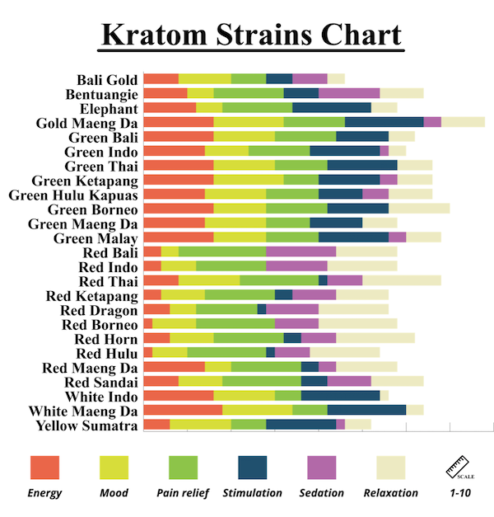
The above chart provides information on various strains that are suits users interests. Unlike synthetic opioids the chemical composition of Kratom is complex and the effects are also dynamic. Kratom’s main alkaloids are speciociliatine, paynanthine, mitragynine. Kratom’s effects are revealed positively at low doses and anxiolytic qualities at higher doses. Each strain has its effects as indicated by the chart. For instance, Bali boosts energy and is an ideal pain reliever and works differently unlike red Kratom (National Institute on Drug Abuse). Red Bali has also some similar characteristics but is known as a versatile strain. Red indo on the other hand is used for sedation.

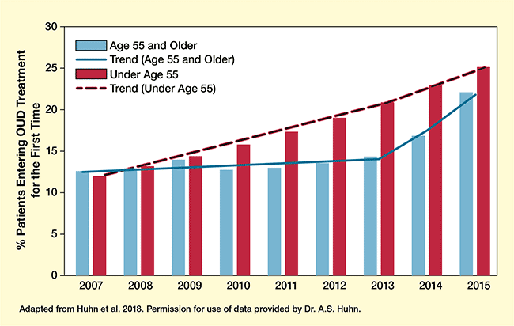
The above indicates how older adults actively use opioid in treatment. Prescription benzodiazepine and opioid misuse has gone up in America among older adults as indicated by the chart with time. Surveys have also indicated widespread polydrug use that has increased suicidal ideation among older people. A large majority confessed that using Kratom conferred a slight risk of health consequences and 23% of adults reported using the drug for medical purposes as prescribed by the doctor unlike most young people who used the drug for leisure.
Conclusion
In summary, Kratom is commonly referred to as Mitragyna speciosa korth is a drug that is mostly found in Southeast Asia, Malaysia, Indonesia and Thailand. As illustrated above, Kratom’s popularity has increased in the U.K and U.S because it is easily accessed online. The drug is purchased from specialist stores and gas stations. The drug is not regulated and does not go through clinical trials or formal testing because it is sold as a supplement. When abused the drug has a narcotic effect that results to negative effects like nausea, dizziness, hypertension, constipation, tachycardia, tremor, sleepiness and confusion. Use of Kratom with other drugs can cause liver and kidney damages and elevated creatinine.

References
National Institute on Drug Abuse. “Kratom Drug Facts.” National Institute on Drug Abuse, 16 June 2020, www.drugabuse.gov/publications/drugfacts/kratom.
Neerman, M. F., Frost, R. E., & Deking, J. (2013). A drug fatality involving Kratom. Journal of forensic sciences, 58, S278-S279.
Swogger, M. T., Hart, E., Erowid, F., Erowid, E., Trabold, N., Yee, K., ... & Walsh, Z. (2015). Experiences of kratom users: a qualitative analysis. Journal of psychoactive Drugs, 47(5), 360-367.
Nicewonder, J. A., Buros, A. F., Veltri, C. A., & Grundmann, O. (2019). Distinct kratom user populations across the United States: A regional analysis based on an online survey. Human Psychopharmacology: Clinical and Experimental, 34(5), e2709.

